Ex2
This code suffers of visibility problems in the shared resources, that is a collection.
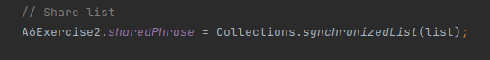
-
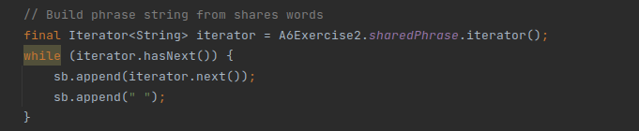Figure 1: problematic section
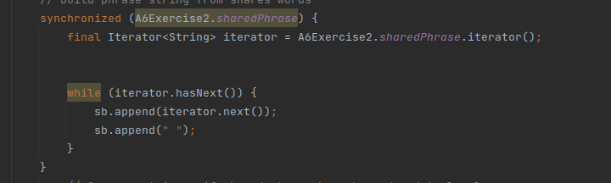Figure 2: first solution
use lock doesn’t give good performance because we lock resource for only once thread, we could use shared list, as following image, but this way suffer of the same problem, performance.

-
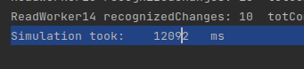Figure 3: lock version execution time
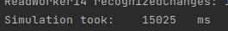Figure 4: sharedCollection execution time

The best solution is use concurrent collections, in this case we use a CopyOnWriteArrayList that works like an ArrayList but supporting concurrence.
final CopyOnWriteArrayList<String> list = new CopyOnWriteArrayList<>();
Figure 5: Concurrenct collection execution time

As we can see in the figure 5 the execution time is faster than the previous solutions

